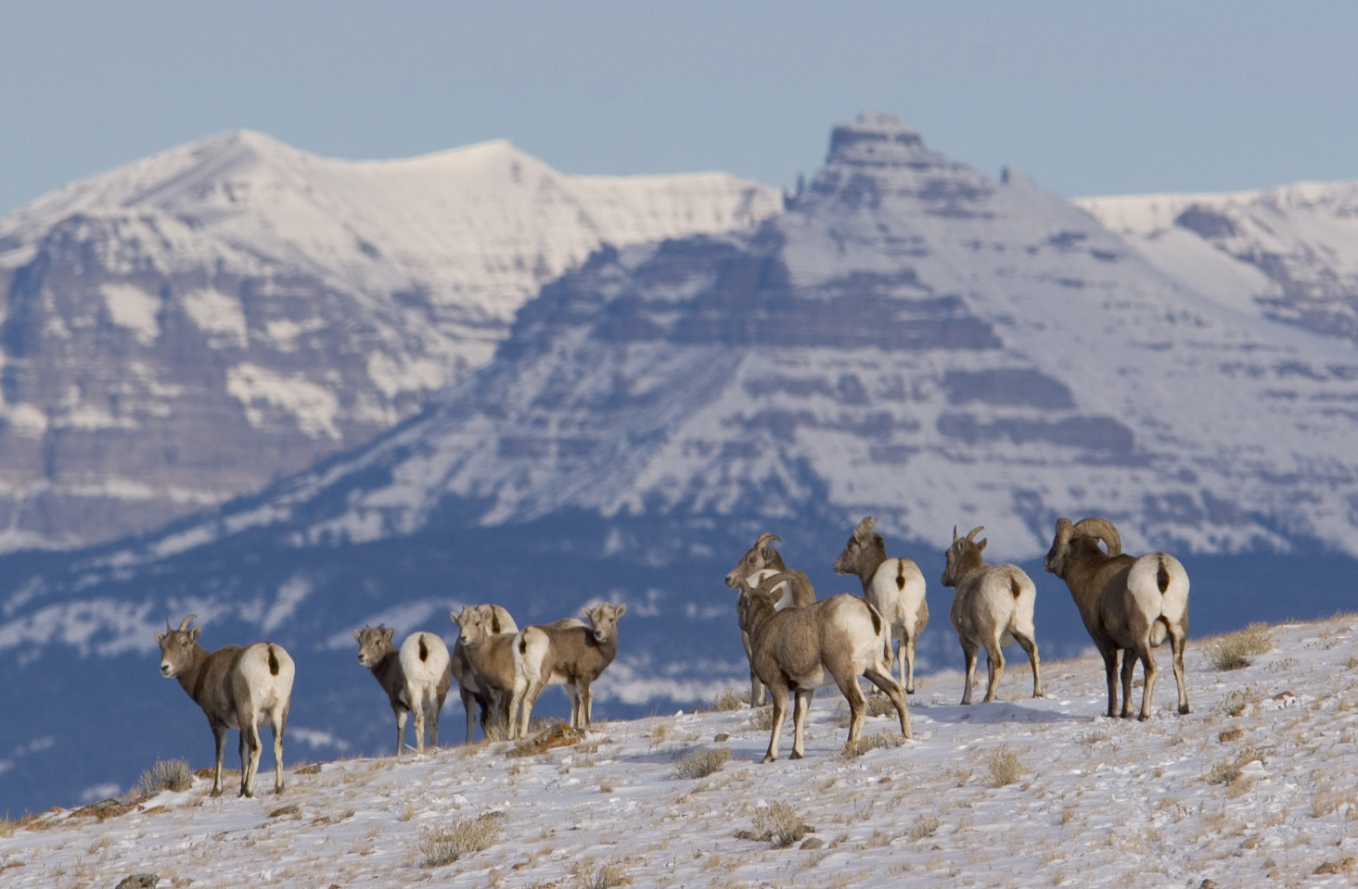
Photo: Mark Gocke
WHISKEY MOUNTAIN BIGHORN SHEEP HERD COLLABORATION
Agenda Workshop 2 of 3
April 3, 6 – 9 pm
Headwaters Arts and Conference Center, Dubois, Wyoming
Objectives:
- Provide summary of February 11 Results
- Provide summary of Scientist Panel results.
- Provide history of habitat work completed and ideas for habitat work.
- Provide history of livestock grazing in Whiskey Mountain area.
- Explore options for solutions related to the Whiskey Mountain Bighorn herd.
- Discuss next steps at next meeting.
6:00 pm Introductions to People and Process. Jessica Western
6:05 Summary of February 11 and Scientist Panel Results Jessica Western
6:10 History of Habitat Work and Livestock Grazing Amy Anderson(WGFD) and
Joe Flowers (USFS)
6:40 History of WMBHS Technical Committee and Public Daryl Lutz
Process Outcomes
6:50 Breakout Groups: Provide WGFD with recommendations to consider in the Whiskey Mountain Bighorn Sheep Herd Strategy.
8:30 Report Back Jessica Western
8:40 Questions and Discussion Jessica and WGFD
8:55 Next Steps Jessica
9:00 Adjourn Daryl

